**Guidelines for the Term Project**

**Data Structures & Algorithms**

**Section:** BSCS-11-A&C **Session:** Fall-2022

**Instructor:** Dr. Yasir Faheem **Due Date:** Monday, January 02, 2023

|  |
| --- |
| **Instructions:**   * One group shall have two members. A group of three is allowed in exceptional cases after getting approval from the instructor. * Evaluation shall be carried out via viva exam.   1. Viva of the weaker student in a group shall determine the overall grade.   2. Plagiarism cases will get zero marks. * To get maximum marks:   1. Assign meaningful names for variables, classes and functions.   2. Use various data structures in this project like different implementations of lists.   3. Use recursion where required in various operations like search, insertion, printing etc.   4. Mention the worst-case and best-case complexities of each of the implemented functions. * Use of array as data container is **discouraged** except in the cases where its requirement can be justified. * Name variables, classes and functions as per C++ programming conventions. Read the attached document entitled, “Naming Conventions in C++ - Coding Standards” prior to continue working on this project. * Comment your code so that it is easy to understand.   1. Above every function's code, a detailed description about its purpose and working principle should be provided. * You must indent your code. Without it, your project won’t be evaluated. |

**Note:**

As discussed in the class, students should either select one of the datasets shared by the instructor or select their own and get it approved by the instructor. Afterwards, they shall write a formal description of their project as is given in the sample shared below. The final application should involve implementing most of the key data structures including AVL trees, graphs, hash tables, and linear data structures like lists, queues, stacks etc. Make sure you choose the most efficient data structure and algorithms based on the requirements of your application. Some sample datasets uploaded [here](https://drive.google.com/drive/folders/1uHGdC5ZSP_1L_kF8VVR_31fDvzY0dj73?usp=share_link). You may download other datasets from <https://data.world/> or other public repositories.

**Deliverables:**

1. A word file containing the complete description of your project in the format given below. It should also include all the source code along with the screenshots of the output for all the key functions.
   1. The title page of the folder should include a table in which you should mention all the data structures you have implemented in your project, a

|  |  |  |
| --- | --- | --- |
| **#** | **Data Structure** | **Purpose** |
| 1 |  |  |
| 2 |  |  |

1. A compressed folder containing your complete source code.

**Instructions for the Oral Exam:**

* Fill out the form that shall be shared with all before the submission date.
* A group-wise schedule shall be shared for the viva exams that are planned to commence in the last week of the semester.

**A Sample Description of a Term Project**

**Description:**

Along, with this document you have been provided a .csv file containing a dataset of 5000 movies downloaded from the website of IMDB. For each of the 5000 movies, details of 28 parameters have been provided like actors, directors, rating etc. You should use this dataset to create a database using various data structures studied in the class. One of your first tasks it to write a parser that extracts information from the csv file for each of the movies. To complete this project, you need to define the below mentioned classes, and implement all operations mentioned in **table 1**. Note that your approach to the problem in terms of defining classes, and functions and organizing data may be different than what is suggested in the guidelines below.

As discussed in the class, you shall need the following classes to organize data in various data structures in your application. Figures numbered 1 and 2 present a visual depiction of how you have to organize data. For details, watch the video recording already uploaded on LMS portal.

**=======================Movie =============================**

A **Movie** Class that should:

1. Store data of all the 28 fields for a movie.
2. Remember, some of the fields like actors, plot keywords, genre etc. in the **Movie** class may contain more than one entry. Such entries should be stored in a suitable data structure such as an array-list or a linked list. You should justify the choice of your data structure during the viva exam. Similarly, plot keywords and genres of a movie are to be stored in a separate data structure. It is better to use enums.

============================ **MovieNode class ===============**

You have to stores all the movies given in the dataset in a suitable data structure. For doing so, you shall need to define a MovieNode class.

Class **MovieNode**{

Movie data;

MovieNode *next;

MovieNode *prev; // in case you use a doubly linked list

}

You may declare an array of MovieNode type to store the dataset e.g. MovieNode MoviesArrayList[Size]. Make sure your decision is backed by logical reasons with focus on the reduction of time and space complexity.

================== **MovieList class** =======================

The MovieList class should provide the following functionalities:

1. A method that:
   1. reads the .csv file one line at a time.
   2. Creates an object of MovieNode class for each movie.
   3. Automatically inserts all the entries of that line in various fields of the data part in the MovieNode object. Note that the data field is of type Movie.
   4. Finally, insert the newly created MovieNode object in your list.
2. Once you have populated all your data structures, then you should implement the functionalities mentioned in table-1

**================= Director Node =====================**

**DirectorNode** class which should store

1. Director’s name
2. A list of movies he has directed.

**Hint:** store a list of pointers to the objects of the movie nodes a director has directed.

1. Provide functionality to
   1. Search directors by name. The search should return name of directors along with the details of the movies they have directed.

**Note:** You shall store the data of all directors in a suitable data structure.

**=====================Actor Node ======================**

**ActorNode** class which should store:

1. The Name of an actor
2. A list of the movies in which he/she has acted. Remember, movies’ data is already stored in a list of type MovieNode class. Thus, the list of actor’s movies should contain only pointers to the MovieNodes in which he/she has acted.

**Note:** Choose a suitable data structure.

=======================================

**A Visual Depiction of How Various Lists are to be Inter-Connected**

As discussed in the class, the below given picture shows how various lists are to be inter-connected:

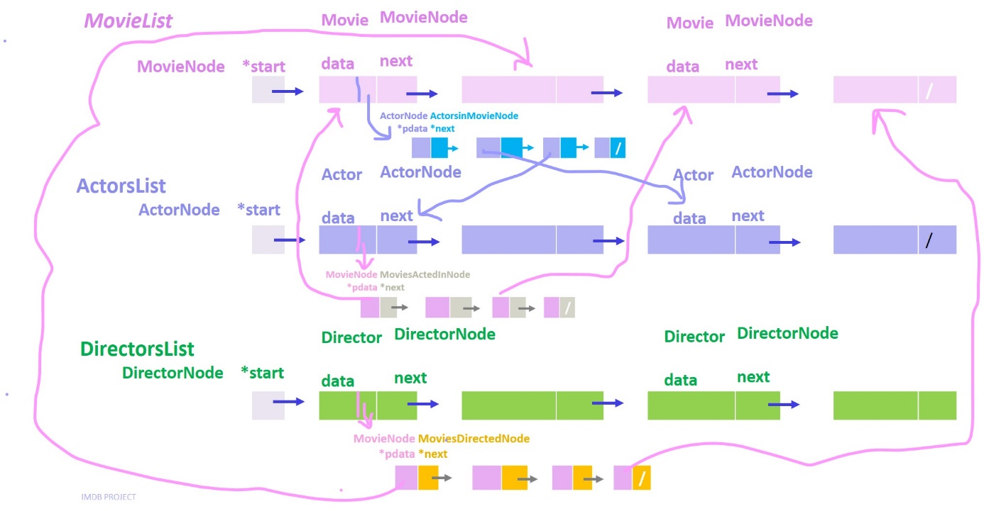

**Figure 1: How to Store and Organize Data**

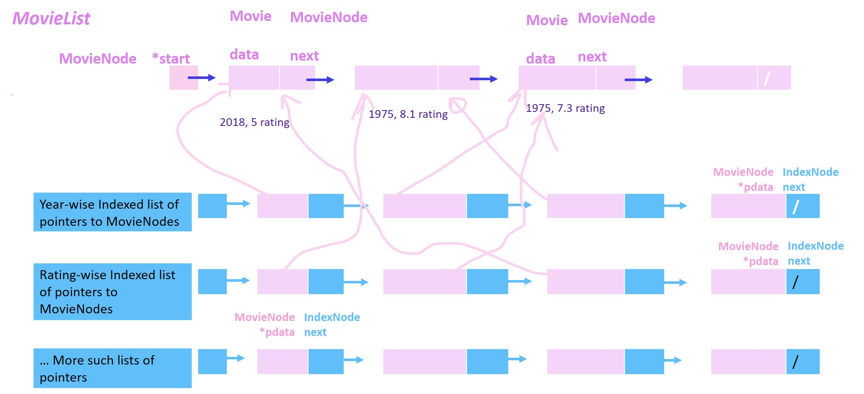

**Figure 2: Indexed Lists of Pointers to Movie Nodes**

**Table 1: List of Functions to Be Implemented**

|  |  |  |  |
| --- | --- | --- | --- |
| **#** | **Operation** | **Input** | **Output** |
| **Functions Related to Actors** | | | |
| 1 | Search profile of an actor | Name of an actor | Actor’s name, count of movies acted in, title of movies in chronological order and their year. |
| 2 | Search co-actors of an actor | Name of an actor | Print all co-actors of the given actor along with the title of the movies. |
| 3 | Search unique co-actors and print them. | Name of an actor | Print the name of all co-actors of an actor only once. For each co-actor, print title of the movies in which both acted in. |
| 4 | Print a list of all co-actors of the co-actors of an actor. | Name of an actor | Suppose an actor A has co-actors B and C in some movie. Each of B and C have their co-actors in other movies as well. For instance, B has co-actors D and E in another movie; C has co-actors F and G in a different movie. Given this example, this function shall print D, E, F and G. Note that these are co-actors of A’s co-actors. |
| 5 | Checks whether A and B are co-actors or not? | Names of two actors e.g. A and B | If A and B have acted together in one or more movies, this function prints their titles. Else, it prints they have never acted together. |
| **Functions Related to Directors** | | | |
| 6 | Search director | Name of a director | Prints all movies a director has directed. |
| 7 | Print directors who have directed movies of a certain genre | Genre e.g. action | Prints the name of all those directors who have directed movies of the input genre type. |
| **Functions Related to Movies** | | | |
| 8 | Search a movie | Movie title (not necessarily complete) | Searches the movies list for the inserted title. If found prints information related to a movie such as its full title, release year, rating, duration, actors, director etc. |
| 9 | Search movies released in a given year | Release year | Prints all movie titles released in the given year. You may store a year-wise index of all movie titles separately. |
| 10 | Print movies year-wise | Options a) increasing order  b) decreasing order | Prints movie titles year-wise. To print contents of a linked list in the reverse order, you may use a stack that stores pointers of movie nodes. Think about it! |
| 11 | Search movies based on genre | Genre e.g. action, adventure etc | Prints movies from highest to lowest rating.   * You may maintain an indexed list of pointers to movie nodes for each genre. * Instead, your function may traverse the list of all 5000 movies and print only the titles for which the input genre matches.   Whichever of these or another option you use, make sure to make decisions that improve the time and/or space complexity while considering nature of the fields in the IMDB dataset. Do provide the worst-case time complexity of your function. |
| 12 | Print movies rating-wise | NIL | Prints movies from highest to lowest rating.   * You may maintain an indexed list of pointers to movie nodes sorted rating wise. * Or, your function may traverse the list of 5000 movies. |
| 13 | Print movies of a certain genre rating-wise | Genre | Prints all those movies rating-wise which match the input genre type. |